Subscribe to Weather Alerts in My IslandID

Introduction
All TAMU-CC faculty and staff may subscribe to weather alerts email notifications for themselves through the My IslandID Self-Service Portal. This service is available courtesy of the Environment Health and Safety Department.

Instructions
- Open a web browser and navigate to My IslandID
- Log in using your IslandID and password (Note: Please update recovery and emergency contact information if prompted.)
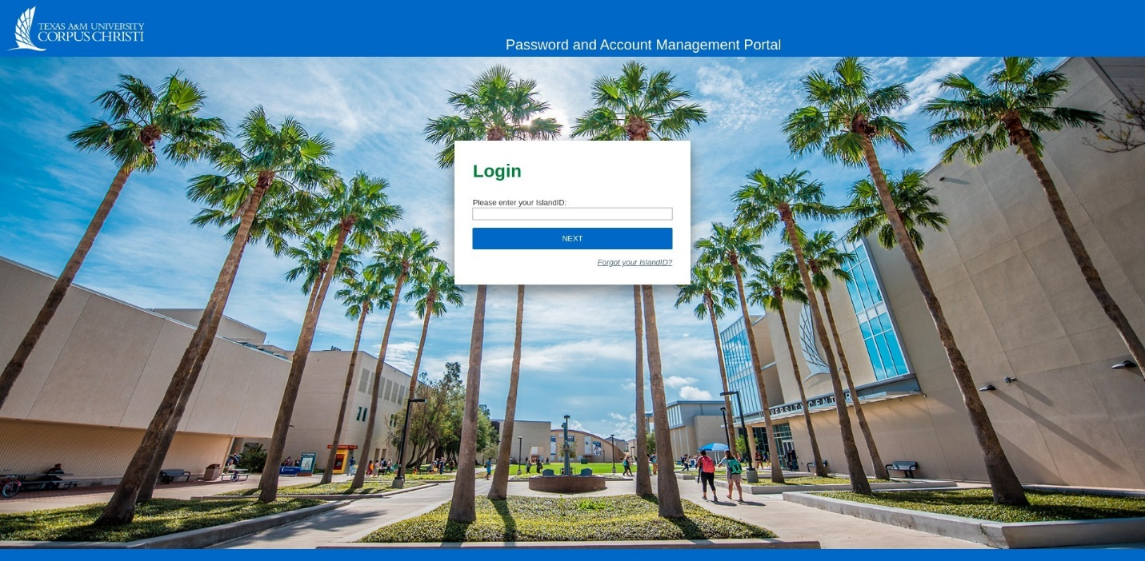

- Select the Requests tab, then the Request Access tab
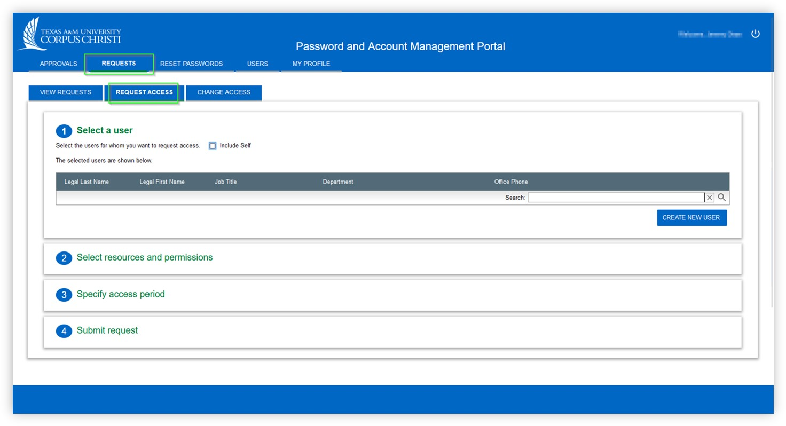

- Check the "Include Self" box to request access for your own account
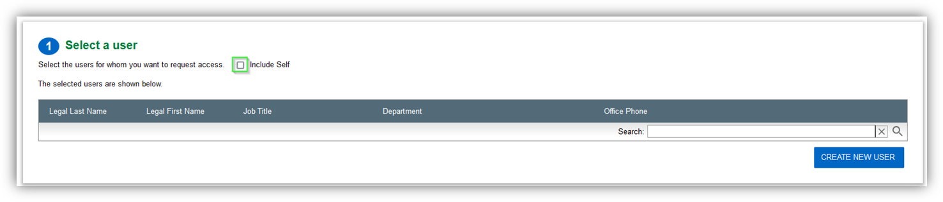
- Using the drop-down menus, select Entitlements > Access Groups > Weather Alerts Mailing List
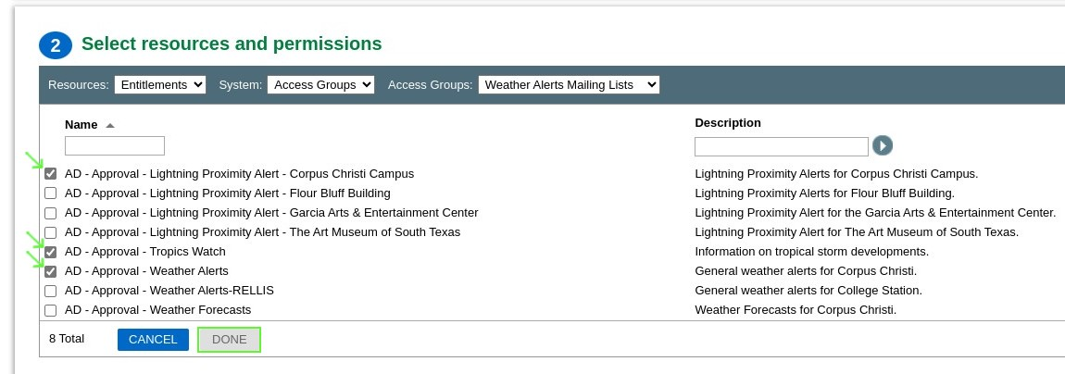
- Check all groups you would like to receive weather alerts for, then click Done.
- Set access period to "Permanent" and enter a brief note (i.e. “Subscribe”) for your request, then select Submit Request
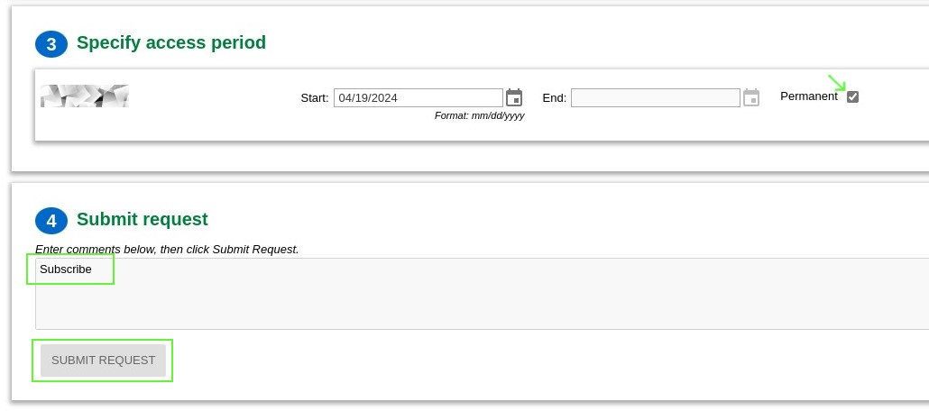

- Your request will be routed to the proper resource for approval, and you will receive an email once subscribed.

Authored by Jeremy Dean
Last modified 2 hours ago
Copy Permalink

