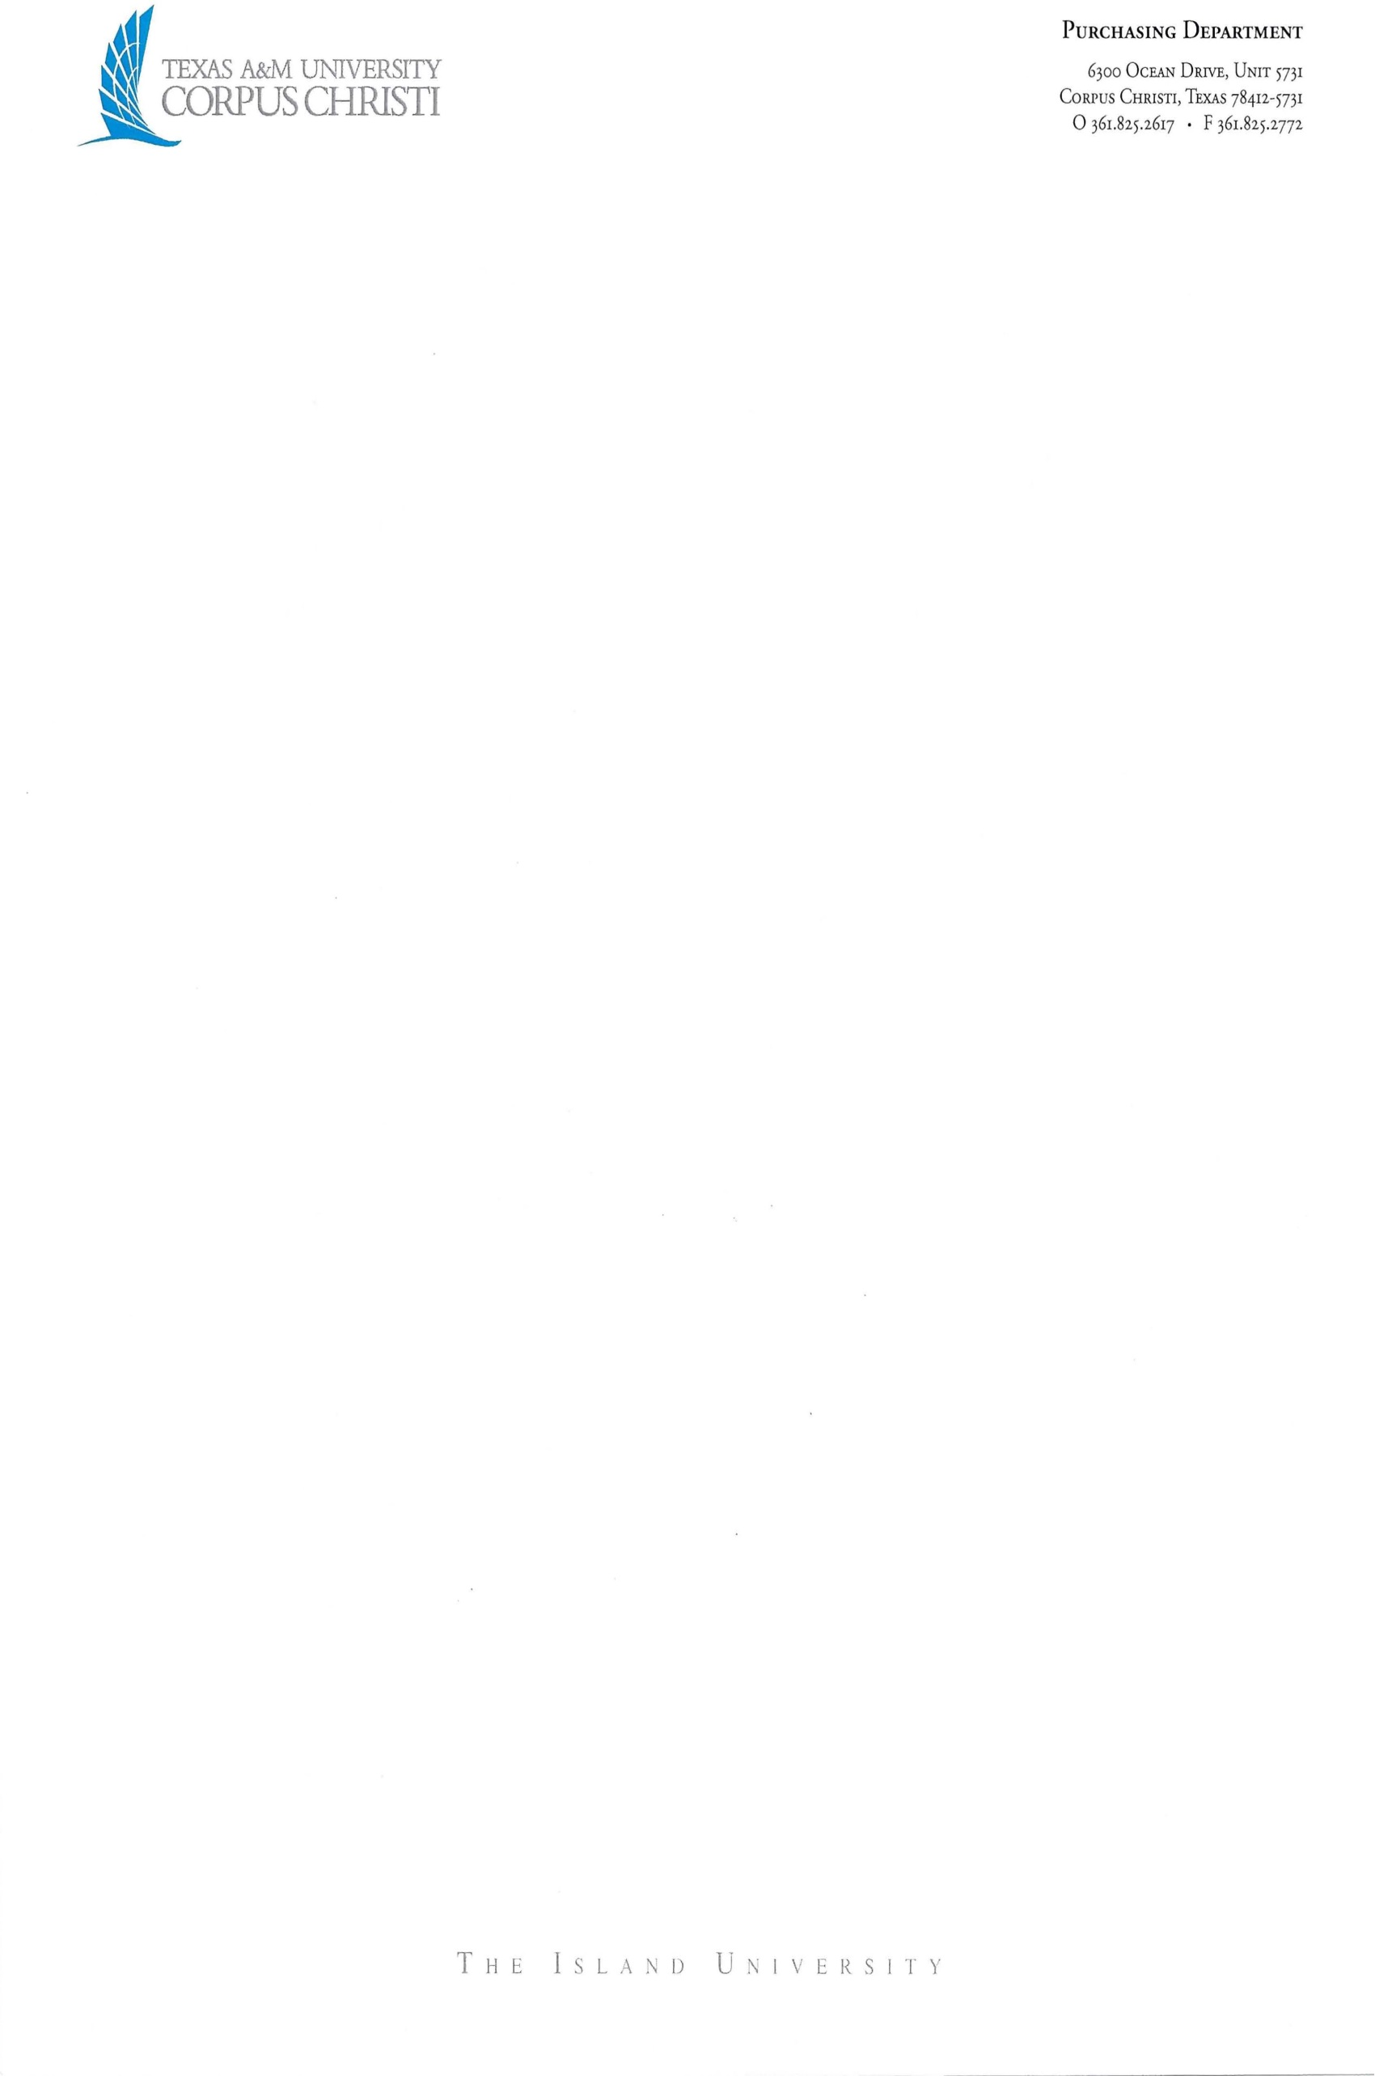

Film Location Agreement
This Film Location Agreement (“Agreement”) is entered into and effective __________ (the “Effective Date”) by and between Texas A&M University – Corpus Christi, a member of The Texas A&M University System (“A&M System”) and an agency of the state of Texas (hereafter referred to as “MEMBER”), and _____________ [Insert Producer’s complete legal name], a ________ [Insert type of entity, such as corporation, limited liability company, partnership, and state of incorporation] (“Producer”).
MEMBER and Producer hereby agree as follows:
- Project Specifics.
  - “Project” means XXXX.
  - “Property” means XXXXX.
  - “Term” means the period for onsite filming and production commencing on or about [DATE] and continuing through [DATE].
- Property.
  - MEMBER grants to Producer and its employees, contractors, agents, licensees and assigns the right to enter, remain on, and occupy the Property during the Term with personnel and equipment for the purpose of recording, filming, taping and/or photographing in connection with the Project and undertaking related activities including making and editing audio and video recordings (including without limitation photographs) on and of the Property.
  - MEMBER grants to Producer the right to record all structures and signs located on the Property, any and all activities, conduct, and conditions occurring or existing on the Property and the right to refer to the Property by its correct name. Producer shall use good faith efforts to use accurate information when Producer identifies, refers to, mentions, or describes MEMBER during the Project (such as MEMBER’s name, mascot, location, or other information that if given incorrectly might create confusion in the marketplace).
  - Producer shall have access and egress from the Property to place all necessary facilities, equipment, and temporary sets and structures on the Property. Upon the expiration of the Term or at any time prior, the Producer shall remove all its facilities, equipment, and temporary sets and structures from the Property and Producer shall restore the Property, including but not limited to landscaping, buildings, fixtures, or utilities altered by virtue of this Agreement, to its original condition reasonable wear and tear excepted and such restoration shall be to the satisfaction of MEMBER and under its supervision.
  - MEMBER will provide Producer with limited access to the Property provided that the Property can be utilized without significantly disrupting or preventing normal MEMBER activities. MEMBER’s representative and Producer’s representative will discuss the use of each specific facility on MEMBER Property required by Producer in connection with the Project and determine the time and manner for use of such facility in connection with the Project, so that such use does not significantly disrupt normal MEMBER functions. Notwithstanding the foregoing, access to and entry in employee and student offices, academic classrooms, laboratories, lecture halls, and residence halls and rooms for purposes of filming, videotaping, photographing and otherwise recording, shall require the approval of MEMBER’s representative and the individuals occupying such facility, space, or room.
  - MEMBER has not inspected the Property as to any existing defects or hazards and specifically does not make any warranty or representation of any type, kind or character, whatsoever, as to existing conditions upon said Property or as to the suitability or non-suitability of the Property for Producer’s purposes. Any person entering upon Property enters at his or her own risk and impliedly accepts Property in the existing conditions.
  - Notwithstanding this Agreement, the day-to-day operation, use, and management of the Property remains the responsibility and function of the MEMBER and its staff. The MEMBER reserves the right to make final decisions relating to the use of the Property and its equipment, furnishings, and fixtures.
  - Should production efforts prove exceptionally disruptive to the operations and functions of MEMBER, Producer, upon written notification by MEMBER, shall immediately cease operations until such time that Producer is able to satisfactorily demonstrate to MEMBER that it can proceed in a manner that is not disruptive to MEMBER. Approval to proceed shall not be unreasonably withheld by MEMBER.
- Ownership of Created Works.
  - All rights of every kind in Producer’s recordings in all manners, formats and media now known or hereafter devised (including without limitation all copyrights therein and all renewals, extensions and restorations of said copyrights) shall be solely owned throughout the universe in perpetuity by Producer; provided that (1) such content is made or produced in accordance with the terms and conditions of this Agreement, and (2) MEMBER grants approval in advance of use of the contents, appearance and presentation of any and all advertising, promotional or other similar materials proposed by Producer utilizing the MEMBER Marks.

- Use of Name and Marks.
  - As set forth and permitted in this Agreement and solely in connection with the Project, MEMBER grants Producer the right to use, not to use, to re-use or reproduce, accurately MEMBER’s name, its designs, trade names, service marks, and all MEMBER’s trademarks and logos, mascots, characters and symbols and other identifying features of the Property that are in existence on the Effective Date of this Agreement, or which will be created during the Term and that are owned, licensed, associated, or otherwise controlled by MEMBER (collectively “MEMBER Marks”). Producer agrees that it shall not graphically change, modify or distort the style and/or appearance of any MEMBER Mark without written approval from MEMBER. Producer agrees that nothing herein shall give Producer any right, title, or interest in the MEMBER Marks, the MEMBER Marks are the sole property of MEMBER, and any use of the MEMBER Marks by Producer shall inure to the benefit of MEMBER.
  - Producer agrees that activities involving its Project bearing the MEMBER Marks will be conducted in such a way as to preserve the goodwill, integrity, character, good name, reputation, and dignity of MEMBER and its Board of Regents, officers, employees, students, alumni and agents.
  - Producer agrees that it shall not use, distribute, exhibit, or exploit MEMBER Marks outside the terms and conditions of this Agreement for commercial purposes.
  - The parties will mutually agree in advance upon any public announcements, or communications to the media regarding this Agreement.
- Releases from Other Rights Holders. As between Producer and MEMBER, Producer has the sole responsibility for securing any and all necessary releases, which includes releases for all students, staff, and parents, location agreements, licenses and permits, provided MEMBER will cooperate in good faith and provide assistance as needed. All releases will require the releasing party to hold MEMBER, its officers, officials, employees, and agents harmless in connection with Producer’s activities hereunder. Producer will also obtain specific releases (in a form to be provided by MEMBER) before any non-directory information on a MEMBER student under FERPA (20 U.S.C. §1232g) will be released by MEMBER to Producer. Producer shall provide copies of all releases to MEMBER prior to production of the Project or within a reasonable period of time after securing such releases.
- Indemnification. Producer shall indemnify and hold harmless MEMBER, its regents, employees and agents (collectively, the “MEMBER Indemnitees”) from and against any third-party claims, demands, damages, liabilities, expense or loss asserted against MEMBER Indemnities arising out of any acts or omissions of Producer or its employees or agents pertaining to the activities and obligations under this Agreement, including but not limited to, all intellectual property issues associated with the Project (copyright, trademark, and trade name infringement), and claims based on any invasion of privacy or unauthorized or inappropriate use of the name, image, or likeness or any person depicted in the Project, except to the extent such liability, loss or damage arises from a MEMBER Indemnitee’s gross negligence or willful misconduct.
- Insurance. Producer shall obtain and maintain for the duration of this Agreement or longer the minimum insurance coverage set forth in Attachment A.
- Compliance with Laws. Producer agrees to comply with all applicable local, state, and federal laws and regulations, and MEMBER rules and regulations, including but not limited to smoking, alcohol, drug, and noise regulations. MEMBER reserves the right to have any individual associated with the Project ejected from the Property for disrupting the operations and functions of MEMBER or for being offensive or derogatory to students, faculty, administrators, or guests of MEMBER.
- Additional Terms and Conditions.
  - This Agreement expresses the entire understanding between the parties with respect to the subject matter hereof and may not be changed, modified, or terminated except in writing. If any provision of this Agreement is adjudged to be void or unenforceable, same shall not affect the validity of this Agreement or of any other provision hereof.
  - This Agreement shall be binding upon and shall inure to the benefit of the parties hereto and their respective heirs, executors, administrators, successors and assigns. It is the intention of the parties to this Agreement that no third parties shall have the benefit of or any rights under any of the provisions hereof.
  - Producer understands and agrees that no student participant shall be provided preferential or special treatment with respect to admission to MEMBER, class assignment, or course schedule because of the participant’s association with the Project.
  - Producer agrees that it shall not knowingly or intentionally film or record in any medium: (1) un-obscured footage of any MEMBER student while such student is nude or partially nude; (2) footage of a MEMBER student(s) using illegal drugs or narcotics; or (3) footage of an underage MEMBER student(s) consuming alcohol. Producer also agrees that it shall not knowingly or intentionally encourage a MEMBER student(s) to commit a criminal act or an act that constitutes misconduct under MEMBER’s Student Code of Conduct. Furthermore, Producer hereby acknowledges and agrees that it is strictly against Producer’s policies to condone, encourage or participate in condoning or encouraging criminal behavior, including but not limited to, the use of illegal drugs or underage consumption of alcohol.
  - Producer may hire or engage one or more subcontractors to perform any of its obligations under this Agreement; provided, however, that (i) Producer shall use the same degree of care in selecting any such subcontractor as it would if such contractor was being retained to provide similar services to MEMBER, and Producer will provide notice to MEMBER of its intention to subcontract and identify such subcontractor to MEMBER prior to the filming date; (ii) Producer shall in all cases remain primarily responsible for all of its obligations under this Agreement with respect to the scope of the Agreement, and shall be responsible for acts and omissions of its subcontractors, their agents and employees; and (iii) all subcontracts under this Agreement shall be consistent with and bound to the terms and conditions of this Agreement.
  - Producer acknowledges that MEMBER is an agency of the State of Texas and nothing in this Agreement waives or relinquishes MEMBER’s right to claim any exemptions, privileges, and immunities as may be provided by law.
ACCEPTED AND AGREED TO by:

Texas A&M University-Corpus Christi |  | [Insert Producer’s complete legal name]
By: ____________________________  Name: ____________________________  Title: ____________________________  Date: ____________________________ |  | By: ___________________________  Name: ___________________________  Title: ___________________________  Date: ___________________________

Attachment A
Insurance Requirements

Producer shall obtain and maintain, for the duration of this Agreement or longer, the minimum insurance coverage set forth below. All coverage shall be written on an occurrence basis. All coverage shall be underwritten by companies authorized to do business in the State of Texas or eligible surplus lines insurers operating in accordance with the Texas Insurance Code and have a financial strength rating of A- or better and a financial strength rating of VII or better as measured by A.M. Best Company or otherwise acceptable to MEMBER. By requiring such minimum insurance, MEMBER shall not be deemed or construed to have assessed the risk that may be applicable to Producer under this Agreement. Producer shall assess its own risks and if it deems appropriate and/or prudent, maintain higher limits and/or broader coverage. Producer is not relieved of any liability or other obligations assumed pursuant to this Agreement by reason of its failure to obtain or maintain insurance in sufficient amounts, duration, or types. No policy will be canceled without unconditional written notice to MEMBER at least ten days before the effective date of the cancellation.

1. Worker’s Compensation

Worker’s compensation insurance with the following minimum limits of coverage:

Statutory Benefits (Coverage A) Statutory
Employers Liability (Coverage B) $1,000,000 Each Accident
$1,000,000 Disease/Employee
$1,000,000 Disease/Policy Limit

Workers’ compensation policy must include under Item 3.A., on the information page of the workers’ compensation policy, the state in which work is to be performed. Workers’ compensation insurance is required, and no “alternative” forms of insurance will be permitted.

If this coverage is waived by System Risk Management, Producer, his/her employees and subcontractors must sign a hold harmless and indemnification agreement.

2. Automobile Liability

Business auto liability insurance covering all owned, non-owned or hired automobiles, with limits of not less than $1,000,000 single limit of liability per accident for bodily injury and property damage.

3. Commercial General Liability

Commercial general liability insurance with the following minimum limits of coverage:

Each Occurrence Limit $1,000,000
General Aggregate Limit $2,000,000
Products / Completed Operations $1,000,000
Personal / Advertising Injury $1,000,000
Damage to rented Premises $300,000
Medical Payments $5,000

The required commercial general liability policy must be issued on a form that insures Producer or its subcontractors’ liability for bodily injury (including death), property damage, personal and advertising injury assumed under the terms of this Agreement.

4. Umbrella Liability Insurance $5,000,000

5. Professional Liability (Errors & Omissions)

Insurance with limits of not less than $1,000,000 each occurrence, $2,000,000 aggregate. Such insurance will cover all professional services rendered by or on behalf of Producer and its subcontractors under this Agreement. Renewal policies written on a claims-made basis will maintain the same retroactive date as in effect at the inception of this Agreement. If coverage is written on a claims-made basis, Producer agrees to purchase an Extended Reporting Period Endorsement, effective for two (2) full years after the expiration or cancellation of the policy. No professional liability policy written on an occurrence form will include a sunset or similar clause that limits coverage unless such clause provides coverage for at least two (2) years after the expiration of cancellation of this Agreement.

6. Additional Requirements

- Producer shall deliver to MEMBER evidence of insurance on a Texas Department of Insurance approved certificate form verifying the existence and actual limits of all insurance prior to the execution and delivery of this Agreement and prior to the performance of any services by Producer under this Agreement. Producer shall provide additional evidence of insurance on a Texas Department of Insurance approved certificate form verifying the continued existence of all required insurance no later than thirty (30) days after each annual insurance policy renewal.

- Commercial General Liability, Aviation Liability (if applicable) and Auto Liability policies must be endorsed to name The Texas A&M University System Board of Regents (“Board of Regents”), and MEMBER as additional insureds up to the actual liability limits of the policies maintained by Producer. The commercial general liability additional insured endorsements must include on-going and completed operations afforded by CG 20 10 (10 01 Edition or equivalent) and CG 20 37 (10 01 Edition or equivalent). Commercial general liability and business auto liability policies must be written on a primary and non-contributory basis. Copies of each endorsement must be submitted with the certificate of insurance. The Umbrella policy, at minimum, must follow form.

- All insurance policies must be endorsed to provide a waiver of subrogation in favor of the Board of Regents, A&M System, and MEMBER.

- All insurance policies will be endorsed to require the insurance carrier providing coverage to send notice to MEMBER ten (10) days prior to the effective date of cancellation, material change, or non-renewal relating to any insurance policy.

- Any deductible or self-insured retention must be declared to and approved by MEMBER prior to the performance of any services by Producer under this Agreement. Producer shall pay any deductible or self-insured retention for any loss. All deductibles and self-insured retentions must be shown on the certificates of insurance.

- Certificates of insurance and additional insured endorsements as required by this Agreement will be forwarded to: contracts@tamucc.edu.

- The insurance coverage required by this Agreement must be kept in force until all services have been fully performed and accepted.

