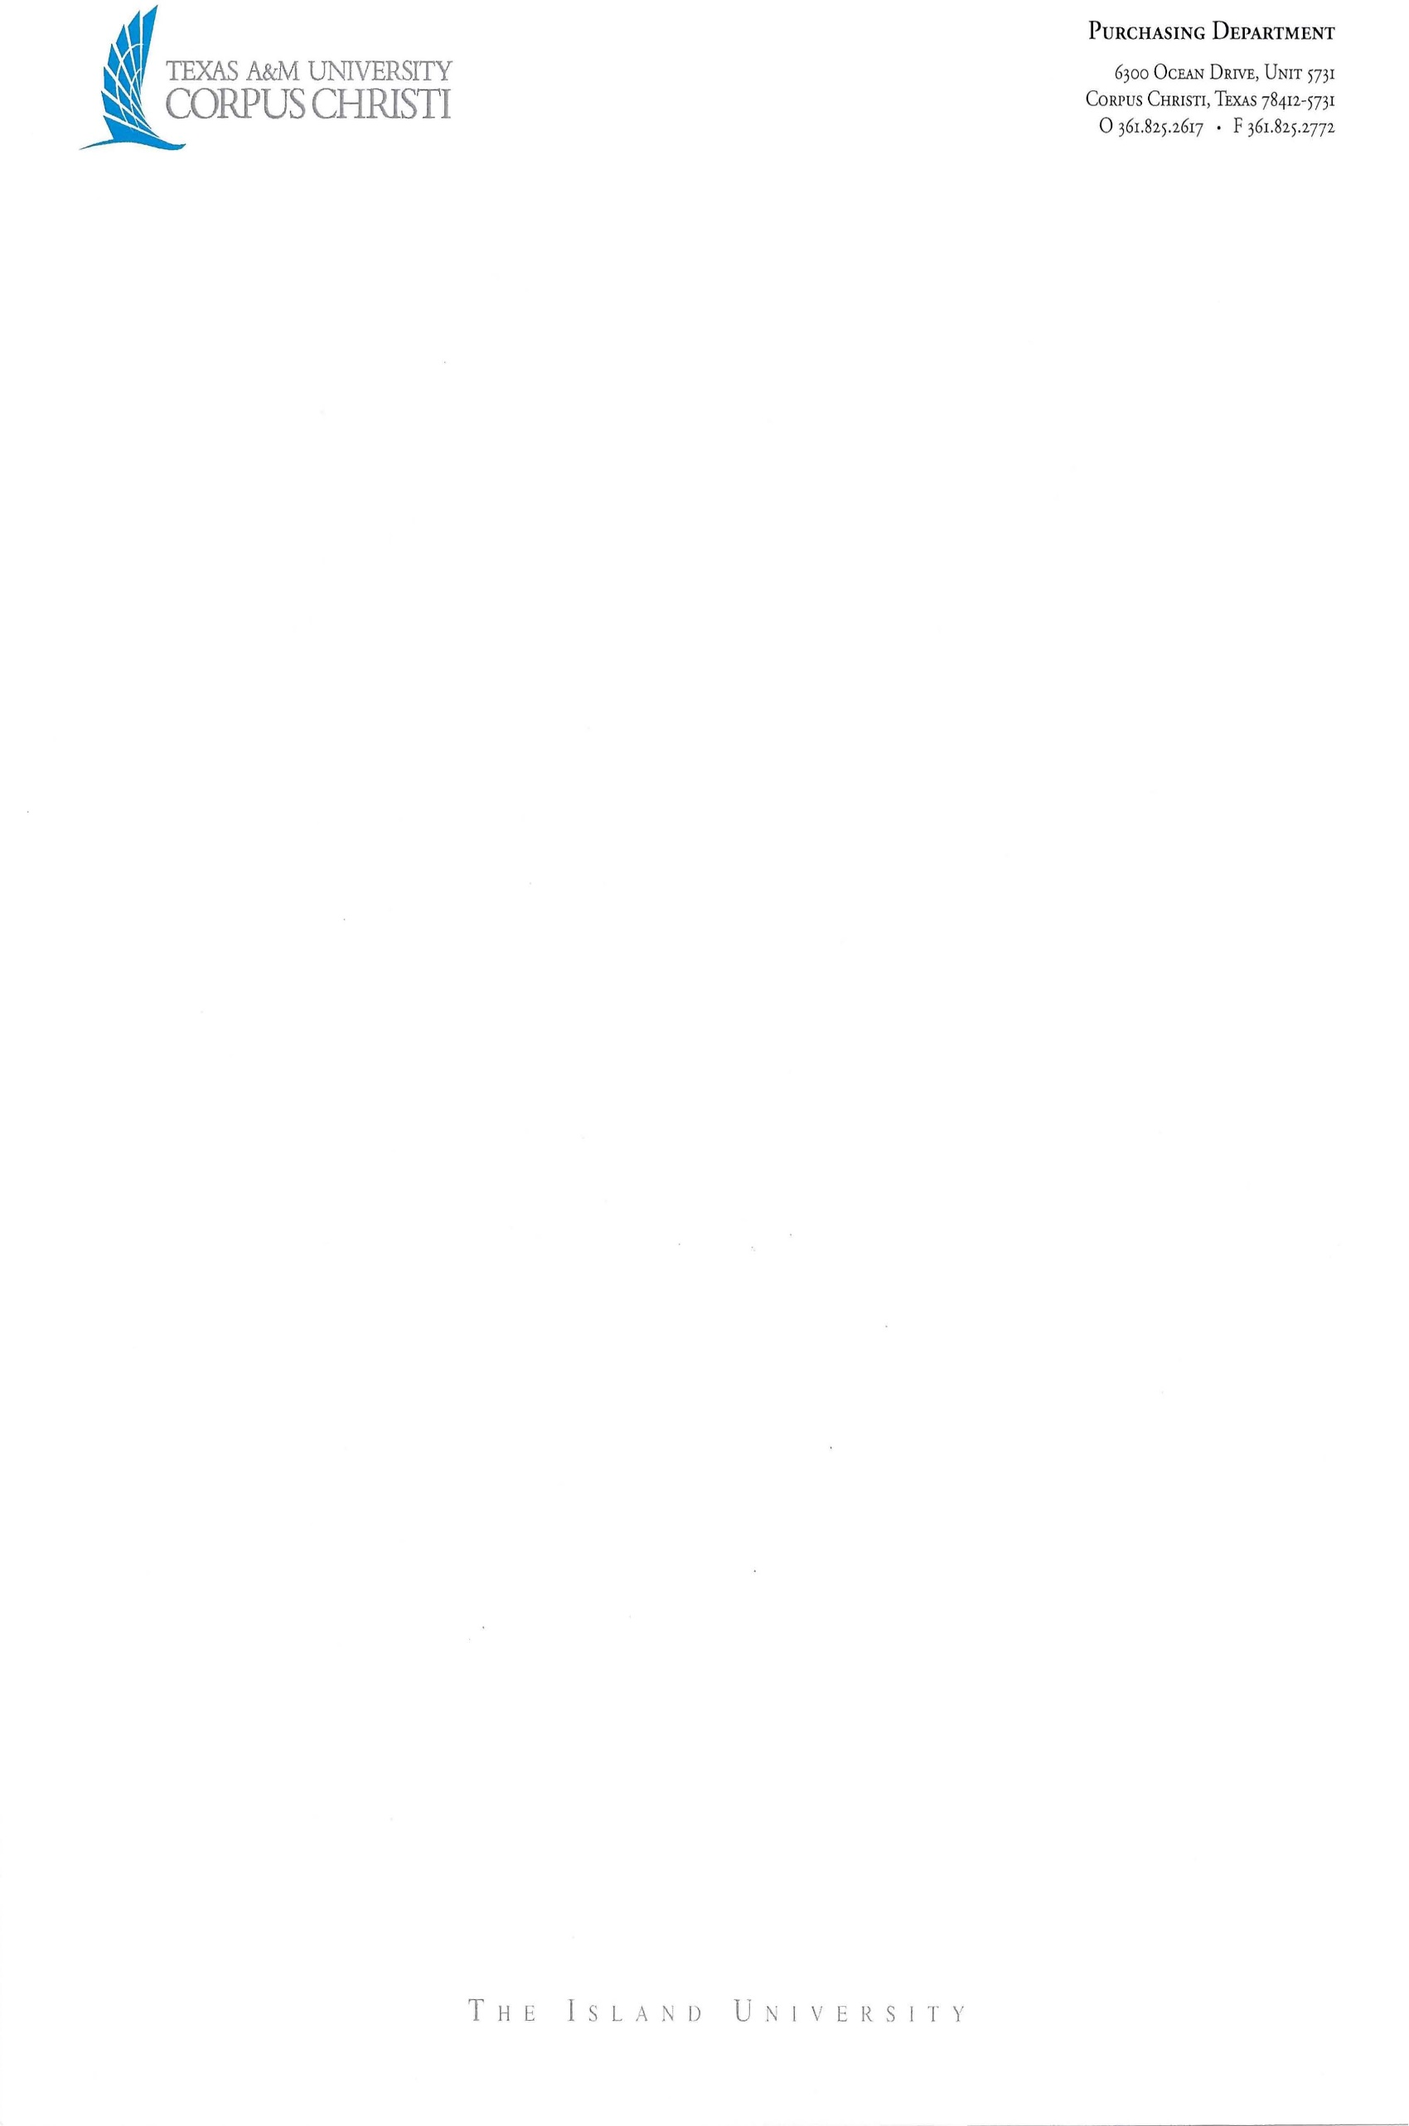

The Texas A&M University System
Presenter Agreement

This Presenter Agreement (“Agreement”) is made and entered into by and between Texas A&M University – Corpus Christi (“MEMBER”), a member of The Texas A&M University System ("A&M System"), an agency of the State of Texas, and [Insert Presenter’s complete legal name] (“Presenter”).

MEMBER hereby engages the services of Presenter for a presentation under the conditions set out below (“Services”):

- Date of Presentation:

- Time of Presentation:

- Topic or Title:

- Location:

- Payment:

No fee will be charged. (If selected Sec. 6 (Payment Method) of this agreement can be disregarded by the parties)

A lump sum/honorarium not to exceed $ and payment will be made thirty (30) days from receipt of accurate invoice, pursuant to Texas Government Code, Chapter 2251 Prompt Payment Act.

- Payment Method: Payment will be made by Direct Deposit. Presenter shall complete and return the appropriate direct deposit form. Form can be located at vendorcare@tamucc.edu

(Please note: all foreign vendors must have a wire transfer in US dollars and complete a Certificate of Foreign Status prior to performance due to IRS withholding requirements. Certificate of Foreign Status goes to TAMU-CC’s local vendor care for tax review and vendor setup). vendorcare@tamucc.edu

- Travel: Presenter’s reimbursable expenses will not exceed the amount of [INSERT AMOUNT]

For reasonable business-related travel, lodging and meal expenses validly incurred directly and solely in support of the Services and approved by MEMBER in advance, Presenter will be reimbursed by MEMBER according to the State of Texas rates, rules, and regulations (https://fmx.cpa.texas.gov/fmx/travel/textravel/rates/current.php). When requesting such reimbursement, Presenter will submit to MEMBER receipts, invoices and other documentation as required by Member. Under no circumstances will Presenter be reimbursed for alcohol purchases. State travel rates are subject to change without notice and will be adjusted accordingly. Mileage rates will be calculated from point-to-point (Presenter’s place of business to job site) using the State of Texas mileage.

No separate travel allowance included.

Transportation (air and/or ground): round trip from to .

Hotel accommodations: [insert applicable info]

Meals:[insert applicable info]

Other: [insert applicable info]

- Recording by MEMBER:

No recording of the presentation is permitted.

Presenter is giving permission for MEMBER to make audio and/or video recordings of this presentation. The Presenter hereby grants MEMBER a limited, free, perpetual, non-exclusive license to use and commercialize the text and recordings of the presentation in any medium as MEMBER desires.

Presenter is giving permission for MEMBER to make audio and/or video recordings of this presentation. The Presenter hereby grants MEMBER a limited, free, perpetual, non-exclusive license to use the text and recordings only for internal MEMBER use and replay.

- Merchandise Sales:

No merchandise may be sold at this presentation.

Presenter shall have the right to sell at the presentation, in a location designated by MEMBER, presentation related merchandise, limited to books, photographs, recordings, clothing or posters. Presenter will collect and remit to the Texas Comptroller of Public Accounts the required 8.25% Texas State sales tax.

Subject to agreement by MEMBER and Presenter, MEMBER may sell books, photographs, recordings, clothing or posters on behalf of the Presenter at the presentation in a location designated by MEMBER. MEMBER will collect and remit to the Texas Comptroller of Public Accounts the required 8.25% Texas State sales tax. MEMBER shall be entitled to an administration fee equal to 25% of the Gross Sales, defined as all moneys collected minus the 8.25% sales tax. All moneys collected will be deposited in the name of MEMBER. A check for the balance will be sent to the Presenter within thirty (30) days after the presentation.

- Presenter Release/Warranty. Presenter grants MEMBER permission to use the name and photo of Presenter in all event promotions. Presenter warrants that he/she is the sole owner of the presentation materials and/or has full power and authority to make this Agreement; that the presentation materials do not infringe any copyright, violate any property rights, or contain any scandalous, libelous, or unlawful matter. Presenter will defend, indemnify, and hold harmless A&M System, MEMBER, its regents, employees, and agents (“Indemnitees”) against all claims, suits, costs, damages, and expenses that the Indemnitees may sustain by reason of any scandalous, libelous, or unlawful matter contained or alleged to be contained in the presentation materials or any infringement or violation by the presentation materials of any copyright or property right; and until such claim or suit has been settled or withdrawn, the MEMBER may withhold any sums due to Presenter under this Agreement.

- Inability to Perform. If Presenter is unable to appear on the dates scheduled due to illness or as a result of a force majeure event (as set forth below), MEMBER will have no obligation to make payments under this Agreement. Should such cancellation become necessary, Presenter shall notify the MEMBER immediately by telephone to staff representative, ____________________ (telephone: _______) followed by an email copy (email: ___________) of the circumstances resulting in the cancellation, with original documentation of circumstances to be provided within forty-eight (48) hours of the initial notice of cancellation. If cancellation by Presenter for any reason other than illness or a force majeure event (as set forth below), Presenter agrees to reimburse MEMBER for any and all documented out-of-pocket expenses, including but not limited to, advertising expenses and local production expenses. Payment will be due in full sixty (60) days from the date of the presentation noted above.

- Force Majeure. Neither party shall be held liable or responsible to the other party nor be deemed to have defaulted under or breached this Agreement for failure or delay in fulfilling or performing any obligation under this Agreement if and to the extent such failure or delay is caused by or results from causes beyond the affected party’s reasonable control, including, but not limited to, acts of God, strikes, riots, flood, fire, epidemics, natural disaster, embargoes, war, insurrection, terrorist acts or any other circumstances of like character; provided, however, that the affected party has not caused such force majeure event(s), shall use reasonable commercial efforts to avoid or remove such causes of nonperformance, and shall continue performance hereunder with reasonable dispatch whenever such causes are removed. Either party shall provide the other party with prompt written notice of any delay or failure to perform that occurs by reason of force majeure, including describing the force majeure event(s) and the actions taken to minimize the impact of such event(s).

- Breach of Contract Claims. To the extent that Chapter 2260, Texas Government Code is applicable to this Agreement, the dispute resolution process provided in Chapter 2260, and the related rules adopted by the Texas Attorney General pursuant to Chapter 2260, shall be used by MEMBER and Presenter to attempt to resolve any claim for breach of contract made by Presenter that cannot be resolved in the ordinary course of business. Presenter shall submit written notice of a claim of breach of contract under this Chapter to the Contracts Officer of MEMBER, who shall examine Presenter’s claim and any counterclaim and negotiate with Presenter in an effort to resolve the claim. This provision and nothing in this Agreement waives MEMBER’s sovereign immunity to suit or liability, and MEMBER has not waived its right to seek redress in the courts.

- Indemnification. Presenter agrees to indemnify and hold harmless Indemnitees from and against any third-party claims, damages, liabilities, expense, or loss asserted against Indemnities arising out of any acts or omissions of Presenter or its employees or agents pertaining to the activities and obligations under this Agreement, except to the extent such liability, loss or damage arises from an Indemnitee’s gross negligence or willful misconduct.

- Independent Contractor. For purposes of the presentation, Presenter is an independent contractor and is not a state employee, partner, joint venturer, or agent of MEMBER. Unless the parties otherwise agree in writing nothing in this Agreement confers a MEMBER faculty title upon Presenter, and Presenter and its employees, agents, and representatives will not represent themselves to be an agent or representative of MEMBER. Presenter acknowledges that MEMBER shall have no responsibility to provide insurance or other fringe benefits normally associated with employee status. Presenter is solely responsible for all taxes, withholdings, and other statutory or contractual obligations of any sort.

- Compliance with Laws. Presenter and its employees, agents, and representatives shall observe and abide by all applicable A&M System and MEMBER policies, regulations, rules and procedures, including those applicable to conduct on its premises. Furthermore, Presenter shall comply with all federal, state, and local laws, rules, and regulations applicable to the performance of its obligations under this Agreement. This includes a restricted party screening if the Presenter is a not a Citizen or a Lawful Permant Resident of the United States.

- Governing Law; Venue. The validity of this Agreement and all matters pertaining to this Agreement shall be governed and determined by the Constitution and the laws of the State of Texas. Pursuant to Section 85.18(b), Texas Education Code, mandatory venue for all legal proceedings against MEMBER shall be in the county in which the principal office of MEMBER’s governing officer is located.

- Payment of Debt or Delinquency to the State. Pursuant to Sections 2107.008 and 2252.903, Texas Government Code, Presenter agrees that any payments owing to Presenter under this Agreement may be applied directly toward certain debts or delinquencies that Presenter owes the State of Texas or any agency of the State of Texas regardless of when they arise, until such debts or delinquencies are paid in full.

- Delinquent Child Support Obligations. A child support obligor who is more than 30 days delinquent in paying child support and a business entity in which the obligor is a sole proprietor, partner, shareholder, or owner with an ownership interest of at least 25 percent is not eligible to receive payments from state funds under an agreement to provide property, materials, or services until all arrearages have been paid or the obligor is in compliance with a written repayment agreement or court order as to any existing delinquency. Under Section 231.006, Texas Family Code, Presenter certifies that it is not ineligible to receive the payments under this Agreement and acknowledges that this Agreement may be terminated, and payment may be withheld, if this certification is inaccurate.

- Public Information. Presenter acknowledges that MEMBER is obligated to strictly comply with the Public Information Act, Chapter 552, Texas Government Code, in responding to any request for public information pertaining to this Agreement, as well as any other disclosure of information required by applicable Texas law. Upon MEMBER’s written request, Presenter will promptly provide specified contracting information exchanged or created under this Agreement for or on behalf of MEMBER to MEMBER in a non-proprietary format acceptable to MEMBER that is accessible by the public. Presenter acknowledges that MEMBER may be required to post a copy of the fully executed Agreement on its Internet website in compliance with Section 2261.253(a)(1), Texas Government Code. The requirements of Subchapter J, Chapter 552, Texas Government Code, may apply to this Agreement and Presenter agrees that this Agreement can be terminated if Presenter knowingly or intentionally fails to comply with a requirement of that subchapter.

- Certification Regarding Business with Certain Countries and Organizations. Presenter represents and warrants that it is not engaged in business with Iran, Sudan, or a foreign terrorist organization, as prohibited by Section 2252.152, Texas Government Code. Presenter acknowledges this Agreement may be terminated immediately if this certification is inaccurate.

- State Auditor’s Office. Presenter understands that acceptance of funds under this Agreement constitutes acceptance of the authority of the Texas State Auditor's Office, or any successor agency (collectively, “Auditor”), to conduct an audit or investigation in connection with those funds pursuant to Section 51.9335(c), Texas Education Code. Presenter agrees to cooperate with the Auditor in the conduct of the audit or investigation, including without limitation, providing all records requested. Presenter will include this provision in all contracts with permitted subcontractors.

- Non-Waiver. MEMBER is an agency of the State of Texas and under the Constitution and the laws of the State of Texas possesses certain rights and privileges, is subject to certain limitations and restrictions, and only has authority as is granted to it under the Constitution and the laws of the State of Texas. Presenter expressly acknowledges that MEMBER is an agency of the State of Texas and nothing in this Agreement will be construed as a waiver or relinquishment by MEMBER of its right to claim such exemptions, remedies, privileges, and immunities as may be provided by law, including the sovereign immunity of MEMBER.

IN WITNESS WHEREOF, the MEMBER and Presenter have entered into this Agreement effective when fully executed by both parties.

Texas A&M University – Corpus Christi | [Insert Presenter’s complete legal name]
By:_______________________________________ | By:_______________________________________
Name:____________________________________ | Name:____________________________________
Title: _____________________________________ | Title: _____________________________________
Date: _____________________________________ | Date: _____________________________________

