Adding Zoom Pro to your Blackboard Course
Instructions
- From the Course Menu, hover over the + sign and select “Tool Link.”
- Enter the name you’d like to be displayed on your course menu.
- From the “Type” dropdown, select “Zoom.”
- Check the “Available to Users” checkbox.
- Click Submit.
- Drag and drop the link to an appropriate spot on your course menu.
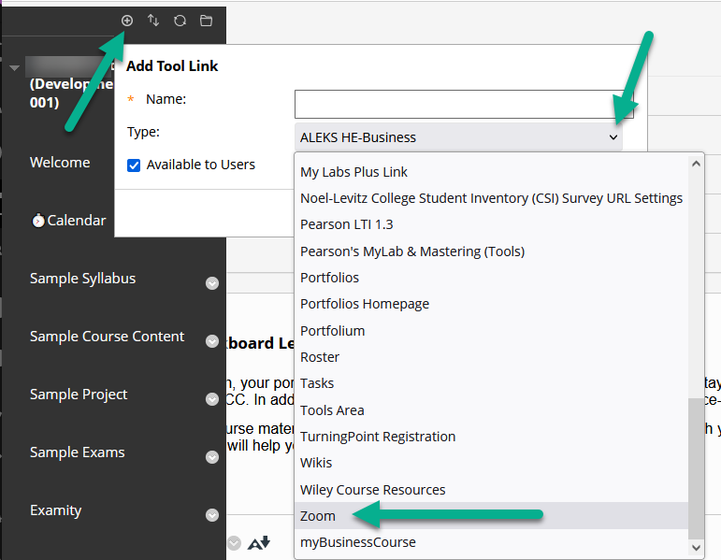

Scheduling your Zoom Meetings
- Click on the “Zoom” link from your course menu.
- Click on “Schedule a New Meeting.”
- Provide a topic/name for your session. Ex. Class Meetings, Office Hours, etc.
- Define when the meeting(s) occurs by selecting the right time and dates. We highly recommend setting recurring meetings with specific days or using the “no fixed time” option under “Recurrence.”
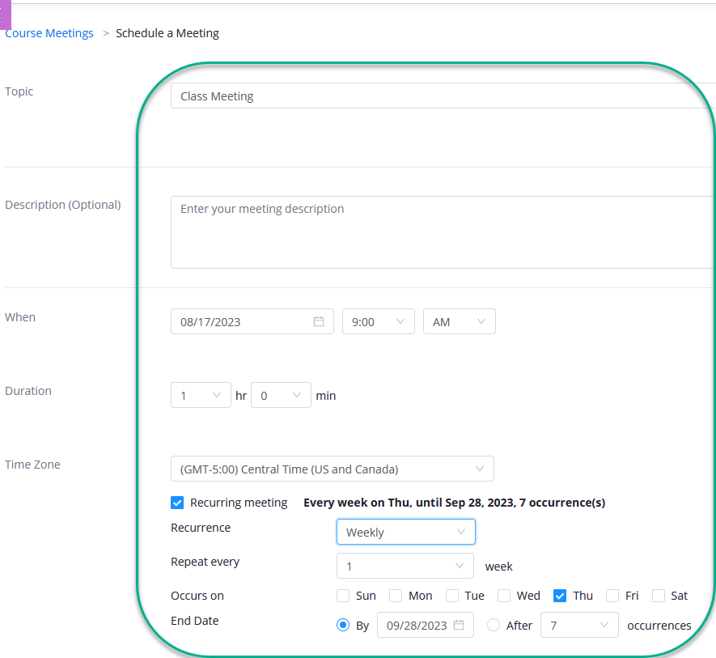
- Do not select Registration. You may only consider this option for students to sign up for office hours meetings.
- Under Security, we recommend leaving the default passcode or setting a new passcode. You may enable “waiting room” and “only authenticated users can join meetings” for extra security.
- Under Video, make any changes as desired.
- Under Meeting Options, we recommend selecting:
  - Mute participants upon entry.
- You may add an alternative host if needed.
- Click on Save to schedule this session.

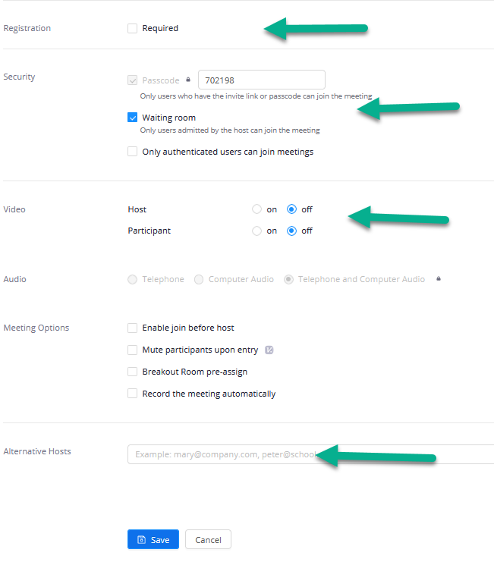

Publish a Zoom Cloud Recording in Blackboard
- Navigate to the Zoom tool in your course.
- Click the Cloud Recordings tab.
- Locate your meeting recording.
- Click the Publish toggle.

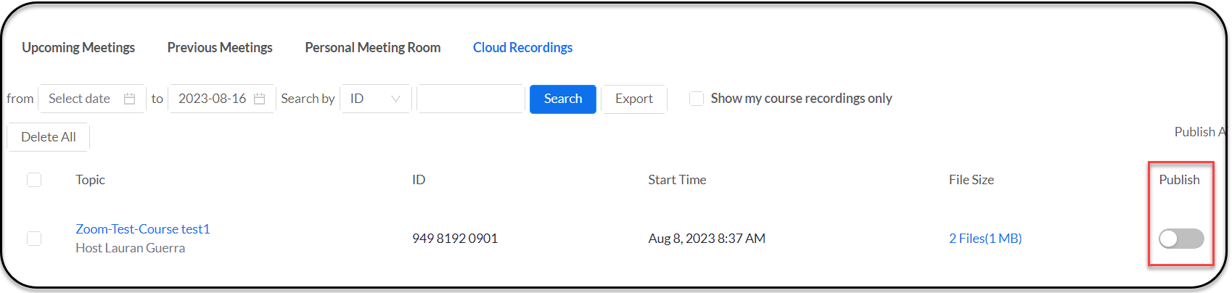

Viewing a Zoom Attendance Report
- Navigate to the Zoom tool in your course.
- Click the Previous Meetings tab.
- Locate your meeting recording.
- Click Report.
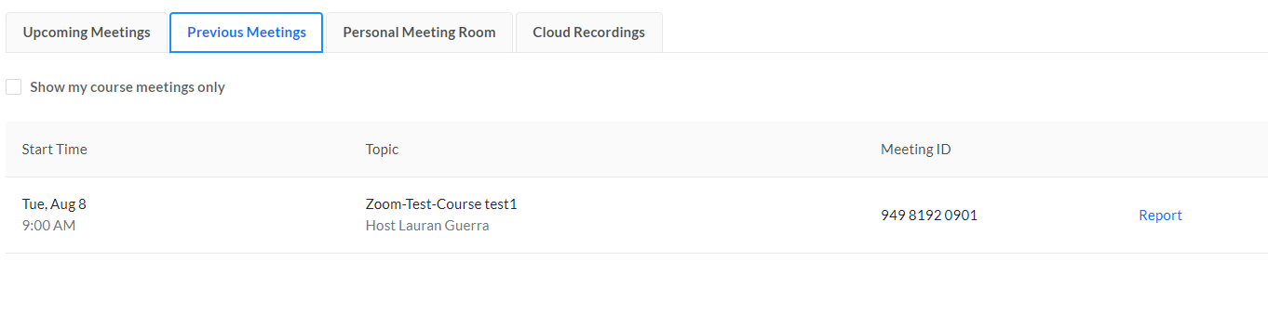

Starting a Zoom Meeting from Blackboard
- Navigate to the Zoom tool in your course.
- Under the Upcoming Meetings Tab, locate the meeting and click on Start Meeting.
- Zoom will begin your meeting and add you to it.
- You can also Delete a meeting from here.
